**How do self-built emotional support communities impact users’ emotions and well-being**

*A Case Study of the “Us” Platform*

**Beijing National Day School**

**Zifang Yu**

**Abstract**

This study explores how self-built emotional support communities can influence users’ emotional states and overall well-being. Using a lightweight browser-based platform, ***Us***, this research simulates user behaviors and employs automated trend analysis to examine emotional and behavioral shifts over time. The platform allows users to form groups based on age, gender, or MBTI type, post emotional updates, receive peer feedback (hugs, encouragement, high-fives), and interact with an AI support companion. Though based entirely on simulated data, results suggest that such self-built emotional ecosystems can foster positive emotional trends, increase user engagement, and provide a foundation for scalable emotional health interventions. The methodology—combining behavioral logging, statistical analysis, and visualization—is replicable and holds promise for future applications using real user data.

1. **Introduction: Background and Research Question**

Mental health challenges—especially loneliness, anxiety, and lack of social connection—are widespread among adolescents, young adults and teenagers.

Despite the popularity of social platforms, many fail to offer meaningful emotional support. Most online interactions are shallow, attention-driven, or filtered through anonymous interfaces that suppress authentic self-expression.

***Us*** was developed in response to this **gap**: a system designed to empower users to self-build emotional communities, find friends, share vulnerable experiences, and offer peer-to-peer encouragement.

The central research question is:

**How do self-built emotional support communities impact users’ emotions and well-being?**

This study investigates whether users, given appropriate tools and group structures, can co-create emotionally nurturing environments that lead to measurable improvements in mood and engagement.

1. **Literature Review**

This study draws from interdisciplinary literature on emotional health, digital communication, and user-centered design:

* According to Cohen and Wills (1985), **emotional support** can play a protective role by reducing psychological stress and strengthening an individual’s ability to cope. [1]
* In a large-scale meta-analysis, Barak et al. (2008) demonstrated that anonymous **online therapy** can effectively lower social anxiety and foster more open emotional communication. [2]
* **Mainstream** digital platforms often center on algorithmic content delivery or broad public feeds—for example, Soul—where authentic emotional expression is frequently discouraged. Their design choices, including attention-grabbing content and intrusive ads, may **reduce** the depth of emotional interaction and contribute to user fatigue or detachment.

***Us*** emphasizes **identity-linked group** formation, **personalized** emotional posting, and **targeted** peer response mechanisms. Unlike general-purpose social platforms, ***Us*** is intentionally designed with a **singular focus on emotional experience**. Every feature—group matching, post creation, reaction types, and AI support—is centered around helping users recognize, share, and improve their emotional states.

1. **Methodology**

This research combines platform development, simulated data modeling, and automated trend analysis.

* 1. **Platform Architecture**

***Us*** is a lightweight HTML5 application supported by Node.js. It operates **without** a centralized backend, using local JSON files for logs and Python for analytics. The platform is divided into three functional areas:

* **Find Us**: Recommends emotion-based **groups** like TeenagerUs, MBTIUs, or StudentUs based on user age, MBTI, or occupation; Users can create their own Us groups.
* **See U**: Allows users to **post** emotional states (moods A, B, or C), attach text/images, and receive reactions—such as hugs, encouragement, or high-fives—from group members.
* **Help U**: Offers a built-in **AI chatbot** using GPT (via us-ai-server) that provides non-judgmental, empathetic responses for anonymous emotional support.

**3.2 Logging & Tracking**

Each interaction triggers a JSON log entry with the following structure:

* **UserId**: Unique identifier for each user.
* **Timestamp**: Time of the action, formatted in ISO standard.
* **Event**: Type of action performed. Examples include:
* **Open\_app**: User launches the application.
* **Join\_us**: User joins a specific emotional group.
* **Post\_emotion**: User posts a mood entry.
* **React\_post**: User sends a reaction (e.g., hug, encouragement, high-five).
* **Comment\_post**: User leaves a comment on someone else's post.
* **Target**: Context or ID relevant to the event. Examples include:
* Mood category (e.g., A, B, C) for posts.
* Post ID for comments and reactions.

These logs form the **basis** for trend analysis and visualization.

**3.3 Data**

**3.3.1 Real Data (Not Used)**

While **not** used for analysis in this paper, the platform supports logging of **real user** behavior via a backend service (us-log-server.js) into the real\_data/ folder. This dual-mode architecture enables future expansion to authentic data collection.

**3.3.2 Simulated Data**

Due to infrastructure limitations and privacy concerns, the current study primarily uses simulated data generated via structured scripts. Scripts like generate-fake-logs.js simulate multiple users with varying behaviors over 7 days, outputting to logs\_fake.json.

**3.4 Analysis Workflow**

**For Real Data**

* **us-log-server.js**: Records live user activity and saves logs into real\_data/logs.json.
* **analyze-log.js**: Aggregates and analyzes actual emotional trends and behaviors based on logs.json and generates summary files like all\_users\_stats.csv.

**For Simulated Data**

* **analyze-fake-log.js**: Aggregates mood posts, reactions, online time, and group engagement by user and date. Exports results as .csv and .json.
* **plot\_fake\_stats.py**: Visualizes mood trends and behavioral patterns per user.
* **generate\_trend\_report.py**: Applies linear regression to mood/emotion metrics and outputs slope and R values for each.
* **Slope**: Measures the daily rate of change; a positive slope indicates upward trends, while a negative slope shows decline.
* **Correlation coefficient (R)**: Reflects the strength and direction of the linear relationship. Values close to ±1 indicate strong correlation.  
  These metrics allow the system to judge whether a user's emotional or behavioral pattern is improving over time.
* **generate\_trend\_summary.py**: Compares emotional/behavioral improvement across users via grouped bar charts.
* **generate\_dashboard.py**: Summarizes nine key charts across users into one dashboard summary.

All scripts run via one unified command and require no manual input, supporting **automated** processing and visualization.

**3.5 System Services and Command Summary**

(This table image is generated by chatGPT)

**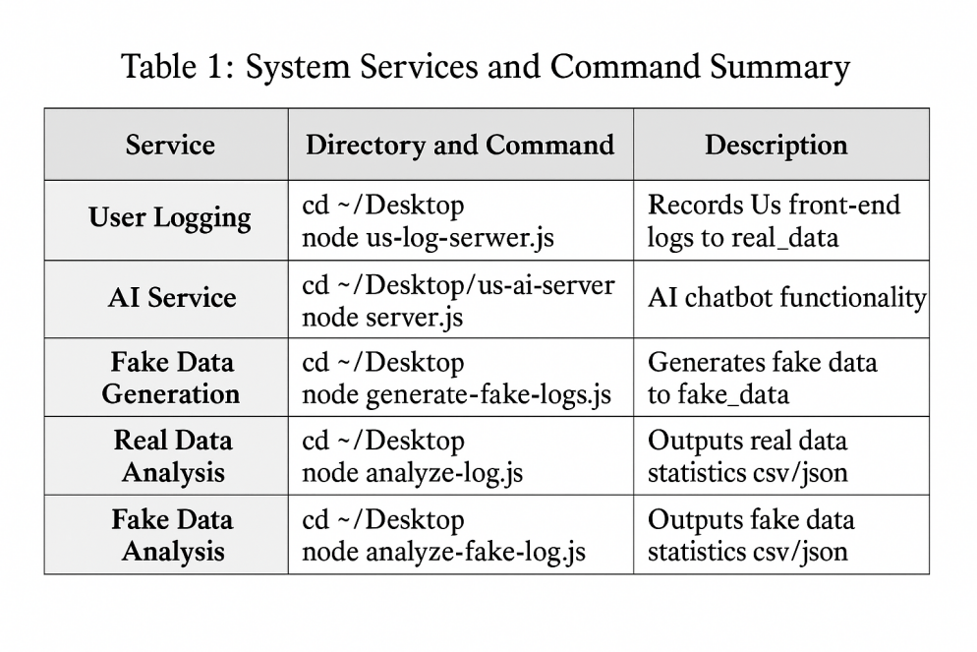**

1. **Results**

*(All results presented in this section are based on simulated user data generated via structured scripts.* ***No*** *real-world user data were used in the analysis.)*

**4.1 Simulated Dataset**

* **Users**: 3 simulated users (testUser001, testUser002, testUser003)
* **Duration**: 7 days
* **Logs**: Over 200 events processed

**4.2 Trends**

Emotional and behavioral trends were derived using **linear regression**, where each metric was analyzed by calculating:

* **Slope**: the daily rate of change.
* **Correlation coefficient (R)**: the strength of the trend.

**Each User**

* **testUser001**: Mood B ↑ (+1.36/day, R=0.93), Mood A ↓ (–0.14, R=–0.21), Mood C ↑ (+0.07, R=0.17), Online time ↑ (+13.5 min/day, R=0.99), All behaviors ↑ (R > 0.82)
* **testUser003**: Mood B ↑ (+1.14/day, R=0.79), Mood A ↑ (+0.29, R=0.49), Mood C ↓ (–0.39, R=–0.57), Online time ↑ (+11.7 min/day, R=0.97), Comment behavior ↑ (+2.39/day, R=0.98)
* **testUser002**: Mood B ↑ (+1.50/day, R=0.82), Mood A ↓ (–0.07, R=–0.10), Mood C ↓ (–0.14, R=–0.13), Online time ↑ (+9.2 min/day, R=0.99), Comment behavior ↑ (+1.86/day, R=0.92)

**Overall**

* **Mood B** (happy/driven) **increased** in all 3 users (↑).
* **Mood A** (sad/lonely) **decreased** in 2 users (↓).
* **Mood C** (anxious/confused) **decreased** in 2 users (↓).
* **All** users showed **rising trends** in:
* Online time
* Join Us participation
* Post Reactions
* Comments
* Emotional posts

**4.3 Visualization**

* **dashboard\_summary.png**: 9-panel user behavior and mood chart

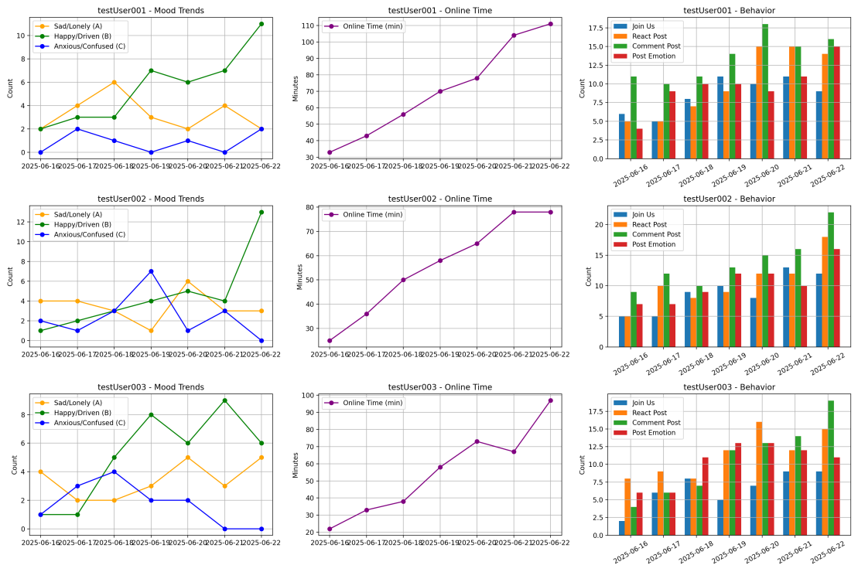

* **trend\_summary.png**: Comparative improvement charts

**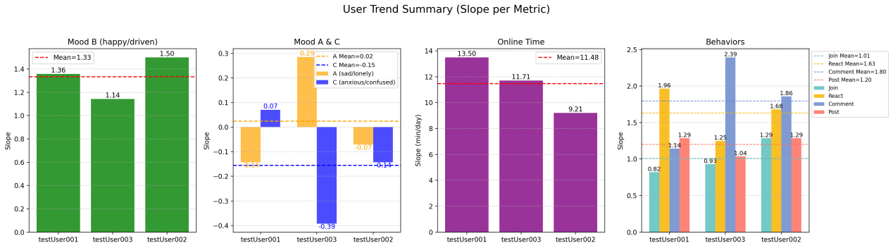**

* **trend\_report.txt**: All metric slopes with statistical correlation

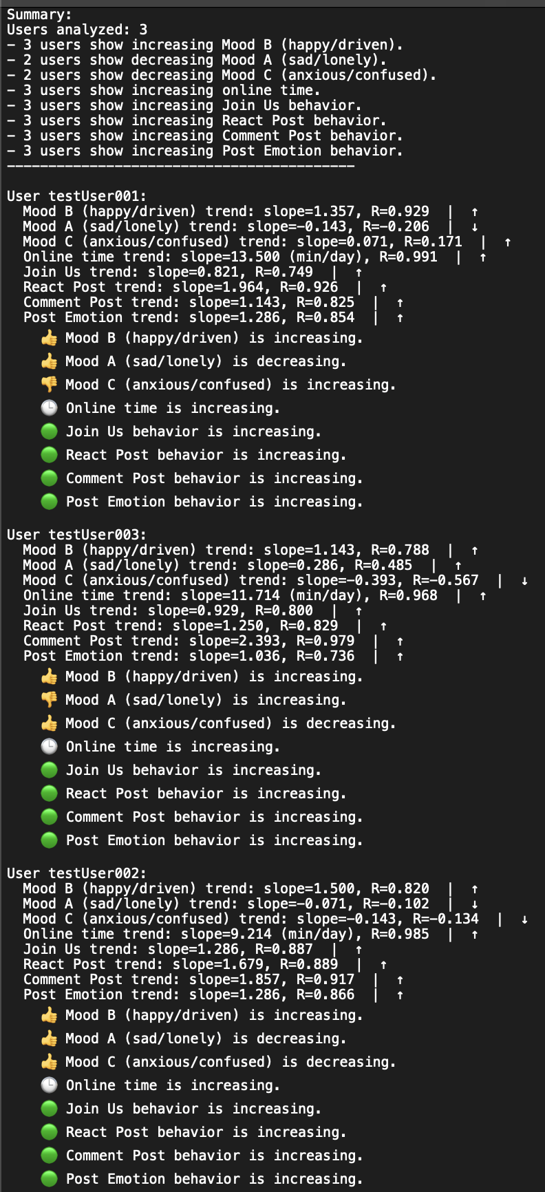

1. **Discussion**

Based on **simulated data**, the findings **support** the hypothesis that self-built communities positively influence emotional well-being. Three insights stand out:

1. **Peer Interaction Encourages Positive Emotion**: Users who received responses (hug, high-five, comment) reported more frequent Mood B posts over time.
2. **Emotional Expression Normalizes Vulnerability**: The open posting of moods reduced anxiety (Mood C), aligning with psychological models of expression therapy.
3. **Engagement Builds Belonging**: Daily use and repeated posting correlated with a reduction in sadness (Mood A), showing that even simulated communities can offer comfort.

Additionally, the automated trend tracking methods demonstrate **strong potential** for real-time monitoring of user emotional health in future implementations involving real users.

While this study is based entirely on simulated data and **cannot** conclusively demonstrate real-world emotional impact, it validates a replicable and scalable **methodology**. The logging framework, behavioral metrics, and automated trend analysis pipeline can be directly applied to real user data in future research. This makes the system not only a **prototype** for emotional support, but also a **practical tool** for continuous mood monitoring and intervention design.

1. **Limitations and Future Work**

* **Simulated Environment**: The current dataset is fully synthetic. Real-world variance, emotion complexity, and unpredictable behavior are absent.
* **Simple Mood Model**: Using only A/B/C mood categories may oversimplify emotional complexity.
* **Short Observation Period**: The 7-day window limits long-term emotional trajectory analysis.

**Next steps** include:

* Deploying a **public** version of Us
* Collecting **real** user data with informed consent
* Expanding **mood types** (e.g., via emoji or sentiment text analysis)
* Applying **machine learning** for emotion clustering and prediction

1. **Conclusion**

This study presents ***Us***, a lightweight, browser-based emotional support platform specifically designed to foster user-driven communities focused on emotional well-being. By integrating group-based interaction, mood expression, and AI-assisted support into one interface, ***Us*** offers a unique environment dedicated to **emotional care**.

While the findings in this paper are derived from fully simulated data and cannot serve as definitive proof of real-world emotional improvement, the observed trends—such as increased happiness, reduced loneliness, and heightened engagement—do align with the intended emotional support goals of the platform. These results suggest that self-built emotional spaces **may** play a positive role in supporting users' emotional states.

Most importantly, this project demonstrates a **replicable methodology**: combining real-time behavioral logging, linear trend analysis, and automated visualization. This approach is scalable, ethical, and adaptable to future applications involving real users.

In this way, ***Us*** serves **not only** as a proof of concept for peer-based emotional support, **but also** as a viable framework for emotional health monitoring and intervention design in broader digital contexts.

1. **Reference**

[1] Leahy-Warren, P. (2014). Social support theory. In J. J. Fitzpatrick & G. McCarthy (Eds.), Theories guiding nursing research and practice: Making nursing knowledge development explicit (pp. 85–101). Springer Publishing Company.

1. Barak, A., Hen, L., Boniel-Nissim, M., & Shapira, N. (2008). A Comprehensive Review and a Meta-Analysis of the Effectiveness of Internet-Based Psychotherapeutic Interventions. Journal of Technology in Human Services, 26(2–4), 109–160. https://doi.org/10.1080/15228830802094429
2. **Appendix**

*This research project and report are fully based on a self-developed platform named “****Us****,” created by the author. All content, figures, data, and analyses are original* ***unless*** *explicitly cited. This paper does not contain material copied from any third-party publication or website.*

**<Us.png>**

**<Us.html>**

**<us-ai-server>**

**<us-ai-server/server.js>**

**<us-log-server.js>**

**<analyze-log.js>**

**<real_data>**

**<real_data/all_users_stats.csv>**

**<real_data/logs.json>**

**<generate-fake-logs.js>**

**<analyze-fake-log.js>**

**<fake_data>**

**<fake_data/all_users_stats_fake.csv>**

**<fake_data/logs_fake.json>**

**<fake_data/plot_fake_stats.py>**

**<fake_data/generate_dashboard.py>**

**<fake_data/generate_trend_report.py>**

**<fake_data/generate_trend_summary.py>**